10

Consent to Share Information
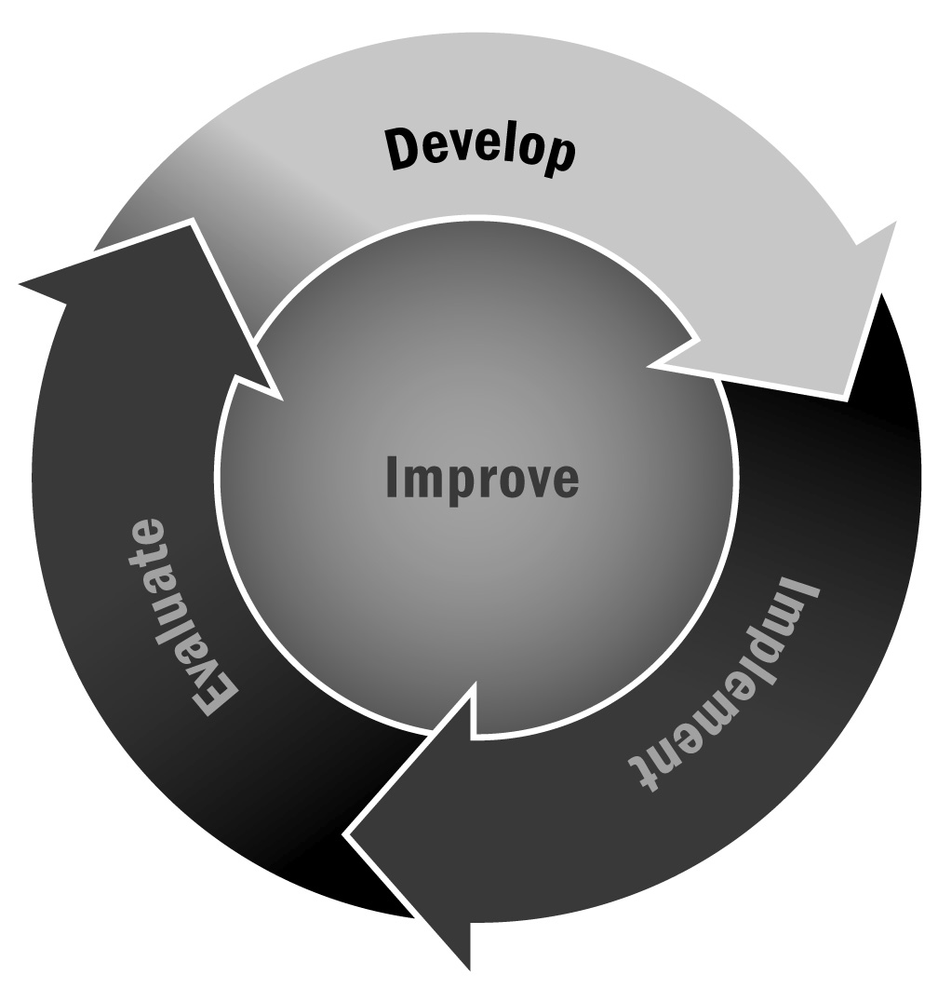
In Chapter 1, you learned that there are a variety of reasons staff members are asked to share participant information and that it is important to establish policies and procedures to protect participants’ privacy and to help staff members respond to requests for information.
Directions: This is a generic consent form that you can customize for your program. Consents should be obtained for a variety of reasons, including photo releases, collecting academic or other data on participant school achievement, for internal program evaluation and related data collection purposes, and sharing information among adults to promote the success of youth. We suggest getting this form signed at the beginning of the program cycle along with the enrollment form. If your program is recruited to participate in a research study of any kind, be sure to ask the researcher for informed consent materials and allow youth and staff members to participate only after they have completed the researcher’s specific consent forms.

ABC Program Consent to Share Information
I authorize the following organizations and cooperating agencies to exchange information related to [Participant Name] (please check all that apply):
- Personal identification information (name, age, birth date, gender, family background)
- School records (grades, standardized test scores, unique identification information)
- Photographs taken during program activities
- Videos taken during program activities
This agreement will expire on [date]:
Name (please print):
Signature: |  |  |  |  | Date:
Relationship:

If your program cooperates with outside organizations or agencies to support a young person’s success (for example, if you share information for an Individualized Education Program), use the following section specifically for data sharing. Using this section permits organizations and cooperating agencies to share confidential information and work together in providing programs for young people. Examples of organizations and cooperating agencies include educational service organizations, social service agencies, law enforcement agencies, mental health service providers, health care providers, and research and evaluation organizations.
For Internal Use
This form has been sent to the following agencies:
Agency Name: |  |  | Date:
Address:
Agency Name: |  |  | Date:
Address:
Agency Name: |  |  | Date:
Address:
This information will be kept confidential by the receiving organization or agency.

